**Functional Document**

|  |  |
| --- | --- |
| **Application** | NGERP - Centra |
| **Service Bundle** | Purchase Management |
| **Service Request** | NTA AP Invoice Confirm |

**Description :**

NTA AP Invoice Confirm screen is used to complete the NTA AP Invoice. The NTA AP Invoice transaction completed will be show here, User have to complete the NTA AP Invoice Confirm inorder to complete the NTA AP Invoice.

**Workflow Process :**

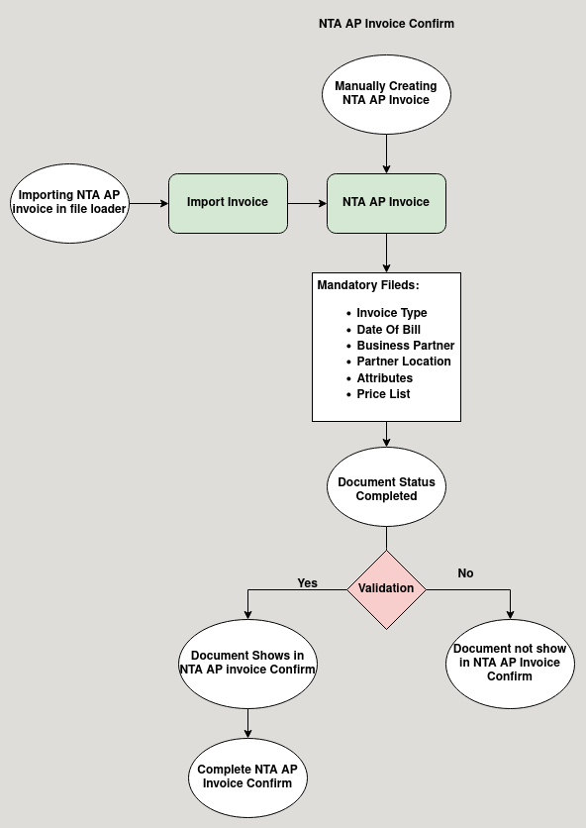

**Business Rules :**

* NTA AP Invoice Screen only Show in HQ.
* This Screen is used to complete NTA AP Invoice .
* There are two ways to do the NTA AP Invoice:
  + Import
  + Manual
* The first method is to import the invoice using file loader in HQ.
* The import Format is 3A NTA AP invoice.
* The imported file will be show in import invoice screen, from their the user should click import invoice to import the NTA AP Invoice to NTA AP Invoice screen.
* The second method is to manually create the NTA AP invoice in the NTA AP invoice screen.
* The user Should fill the mandatory field listed below to complete the NTA AP Invoice
  + Invoice Type
  + Date of Bill
  + Business Partner
  + Partner Location
  + Attributes
  + Price List
* After Adding lines in NTA AP Invoice click Complete to prepare the document.
* To complete the document go to NTA AP Invoice Confirm Screen.
* Click Complete to complete the NTA AP Invoice.
* After completing the NTA AP Invoice Confirm, the NTA AP Invoice is also completd.